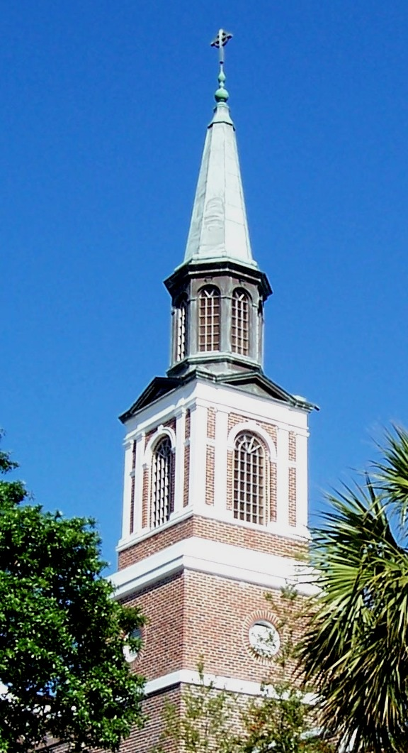

**Welcome to**

**First Presbyterian Church**

**of Ocala**

**Our Vision – Our Mission**

To spread the gospel of Jesus Christ to our community and the world.

To be an inclusive downtown community of faith that seeks to embrace everyone in growing spiritually.

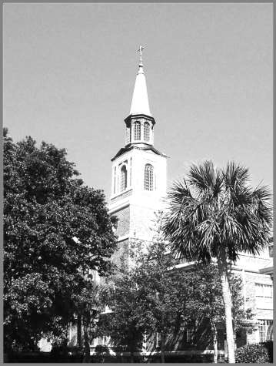

**162 years in Historic Downtown Ocala**

March 1, 2020

This Morning’s Communion Meditation

“Perseverance”

The Rev. Dr. D. Ronald Watson, Jr., Pastor

511 S.E. Third Street | Ocala, FL 34471

Phone: (352) 629-7561 | Fax: (352) 629-8066 | Website: [www.fpcocala.org](http://www.fpcocala.org)

**Traditional Worship**

**The Lord’s Day**

**March 1, 2020**  **8:15 and 11:00 a.m.**

**We Gather with Others in God’s House**

Chiming of the Hour

Welcome and Announcements

**We Prepare Our Hearts and Minds for Worship**

Prelude  I Need Thee Every Hour Robert Lowry

arr. by Gail Smith

Introit Christ, We Do All Adore Thee     Theodore Dubois

Call to Worship

Leader: To you, O Lord, I lift up my soul. Lead the humble and teach them your way.

**People: Make me to know your ways, O Lord; teach me your paths.**

Leader: For you are the God of my salvation; for you I wait all the day long.

**People: Your paths are steadfast love and faithfulness for those who keep your decrees.**

Leader: Let us worship God!

**We Give Praise and Adoration to God**

*Hymn of Praise O For a Thousand Tongues to Sing #610

*Prayer of Praise and the Lord’s Prayer (Unison)

**Our Father who art in heaven, hallowed be Thy name. Thy kingdom come, Thy will be done, on earth as it is in heaven. Give us this day our daily bread; and forgive us our debts, as we forgive our debtors; and lead us not into temptation, but deliver us from evil.  For Thine is the kingdom and the power and the glory, forever. Amen.**

*Gloria Patri Glory Be to the Father #581

**Glory be to the Father, and to the Son, and to the Holy Ghost; as it was in the beginning is now, and ever shall be, world without end. Amen, amen.**

*If able please stand

Prayer of Confession (Unison)

**Have mercy upon us and hear our prayer, O God. We have failed to live in the light of your covenant. You set your rainbow above us, yet clouds of unbelief darken our days. Distrust wells within us; fear, not hope, is our watchword. Your beloved bids us follow, but we are slow to obey. Without your grace, we are fruitless and inert. In mercy renew us and bring us to life, through Jesus Christ.**  *(time for silent confession)*

Assurance of Pardon (Leader)

Amen. Remember that Christ died for sins once and for all, that he might bring us to God cleansed of unrighteousness. “Baptism now saves you—not as removal of dirt from the body, but as an appeal to God for a good conscience, through the resurrection of Jesus Christ.” Remember your baptism and live in new life, assured of forgiveness through Christ, who intercedes on our behalf.

Passing of the Peace May the Peace of Christ be with you **And also with you**

Choir Anthem (11:00 a.m.)  "Come to the Welcome Table"     Joseph M. Martin

I'm gonna sit at the welcome table, O Lord, I'm gonna sit at the welcome table, one of these days. Hallelujah! Let us break bread together on our knees. Let us break bread together on our knees. When I fall on my knees, with my face to the rising sun, O Lord, have mercy on me. Let us drink the cup together on our knees. Let us drink the cup together on our knees. When I fall on my knees with my face to the rising sun, O Lord, have mercy on me. O, I'm gonna sit at the welcome table, O Lord, I'm gonna sit at the welcome table, one of these days. Hallelujah! I'm gonna sit at the welcome table, one of these days. We will feast in one accord, at the table of the Lord, We will sit at the table with Jesus, one of these days. Hallelujah! One of these days.

Prayers of the People

Offertory      Holy, Holy, Holy John Dikes

arr. by Sharon Wilson

*Doxology Praise God, from Whom All Blessings Flow                                    #606

**Praise God, from whom all blessings flow. Praise him, all creatures here below;**

**Praise him, above, ye heavenly host; Praise Father, Son, and Holy Ghost. Amen**

**We Hear God’s Word Proclaimed**

First Scripture Reading           Romans 5:12-19 (N.T. page 189)

Second Scripture Reading        Matthew 4:1-11 (N.T. page 3)

This is the Word of the Lord **Thanks be to God**

Communion Meditation   “Perseverance”

Hymn Draw Us in the Spirit’s Tether #529

**Celebration Of The Lord’s Supper**  (All are welcome and invited to participate)

**We Respond to God’s Word**

*Affirmation of Faith (Unison)   The Apostles’ Creed

**I believe in God, the Father almighty, Maker of heaven and earth, and in Jesus Christ his only Son, our Lord; who was conceived by the Holy Ghost, born of the Virgin Mary, suffered under Pontius Pilate, was crucified, dead, and buried; he descended into hell; the third day he rose again from the dead; he ascended into heaven, and sitteth on the right hand of God the Father Almighty; from thence he shall come to judge the quick and the dead. I believe in the Holy Ghost; the holy catholic church; the communion of saints; the forgiveness of sins; the resurrection of the body; and the life everlasting. Amen.**

**We Depart to Live and Love as Christian Disciples**

*Sending Hymn    A Mighty Fortress Is Our God #275

*Charge and Benediction

Response (11:00 a.m.) May the Grace of Christ Our Savior     John Stainer

Postlude Postlude in G Joseph Vockner

 

*The flowers in the sanctuary today are given to the Glory of God*

PRAYER LIST

**Renate Lipp** (Nita William’s friend)

**Kevin Lloyd** (Lee Ann Drake’s cousin)

**Celine Mack**

**Skip McDonald**

**Jerry Murphy**

**Raul Nieves** (Mina DiGeronimo’s brother)

**Greg Robinson** (Carolyn Varner’s brother)

**Michael Rou** (Dr. David Albright’s cousin)

**Janice Schafer** (Palm Garden)

**Tom Schurlnigh** (Ellen Matthews’ cousin)

**Deloris, Steve and Keith Shotwell**

**Howard Tucker**

**Nancy Wells** (Daughter of Shirley Wells)

**Shirley Wells** (The Lodge)

**Jill Hester Whitaker**

**Bo and Sally Williams**

**Thomas and Debbie Ault**

**Pam Butcher**

**Andy Carlisle**

**Sara Chey, Brenda Jones and family**

**Shirley Cochran**

**Stewart and Diane Edwards**

**Hank and Maranell Fleming**

**Bill Green** (Richard Grosso’s friend)

**Richard Grosso**

**Barbara Gowie**

**Dick Hancock**

**Jordan Kaufman** (applying for medical school)

**Ken Kramer** (Evelyn Longo’s brother-in-law)

**Kathy Lance** (Lois Lance’s daughter-in-law)

**Lois Lance**

**Grietje Lewis**

|  |  |
| --- | --- |
| **Serving Today at First Presbyterian Church of Ocala** | |
| **Elder of the Day** | Amy Johnson |
| **Ushers 11:00** | Don McCormick, Dave Bice, Lamar Knepp, Don Hutto, Pat Bishop, Joe Simmons,  Steve Vincent, Roxanne Schwaller, John Reiss, Bob Timmer |
| **Communion**  **Servers 8:15** | Van Akin, Sandra Owens, Howell Winfree, III, Donna Winfree |
| **Communion**  **Servers 9:30** | Cindy Andrews, Jeff Baker, Margaret Baker |
| **Communion**  **Servers 11:00** | Jo Ann Brandt, Jackie Albright, David Albright, JJ Albright, Peggy Wiechmann, Derek White, Roxanne Schwaller |
| **Acolyte** | Bentley Johnson |

|  |  |  |
| --- | --- | --- |
| **Calendar**  **March 1 – March 7, 2020** | | |
| **SUN.** | **March 1**  8:15 a.m.  9:30 a.m.  11:00 a.m.  8:15 a.m. – Noon  9:45 a.m. – 10:30 a.m.  9:45 a.m.  12:15 p.m. | **Worship Services**  **Traditional Worship** (Sanctuary)  **Contemporary Worship** (Fellowship Hall)  **Traditional Worship** (Sanctuary)  **Children and Youth Ministries**  **Nursery**: *Newborns – 3 year olds* (Nursery)  **Children’s Church**:*4 years – 5th Grade (*Room 26)  **Adult Sunday School Class**  **The Blakely Class** (The Parlor)  **Stated Session Meeting** (Fellowship Hall) |
| **MON.** | **March 2**  5:00 p.m. | **Building and Grounds Committee meeting** (Room 1) |
| **TUES.** | **March 3**  10:30 a.m.  2:00 p.m.  5:30 p.m.  6:00 p.m.  7:00 p.m. | **Faith Sisters** (Parlor)  **Membership meeting** (Conference Room)  **PW Bible Moderator Mentoring** (Room 1)  **Cross and Crown Band Rehearsal** (Fellowship Hall)  **PW Coordinating Team** (Room 1) |
| **WED.** | **March 4**  10:00 a.m.  1:00 p.m.  4:00 p.m.  5:00 p.m.  6:15 p.m. | **Disciple XV** (Room 1)  **Fellowship Committee meeting** (Conference Room)  **Children’s Choir rehearsal** (Choir Room)  **Choir rehearsal** (Choir Room)  **Handbell Choir rehearsal** (Bell Room) |
| **FRI.** | **March 6**  9:00 a.m.  10:30 a.m. | **Church Women United** (Fellowship Hall)  **Griefshare** (Conference Room) |

Contemporary Worship Service

9:30 a.m.

Ushers: Tommy and Amy Johnson

Acolyte: Bentley Johnson

Guest Musician: Leslie Athanason

**Welcome and Announcements**

**Praise Music** Trading my Sorrows 10,000 reasons Lord I Need You

**Passing of the Peace**

**Children’s Time**

**Prayers of the People and the Lord’s Prayer (Unison)**

**Our Father who art in heaven, hallowed be Thy name. Thy kingdom come, Thy will be done, on earth as it is in heaven. Give us this day our daily bread; and forgive us our debts, as we forgive our debtors; and lead us not into temptation, but deliver us from evil.  For Thine is the kingdom and the power and the glory, forever. Amen.**

**Offertory** Undo Me (Leslie Athanason and Chris Story)

**First Scripture Lesson** Romans 5:12-19

**Second Scripture Lesson** Matthew 4:1-11

**Communion Meditation**  “Perseverance” Dr. Watson

**Communion**

**Affirmation (Unison)**

**In life and in death we belong to God. Through the grace of our Lord Jesus Christ, the love of God, and the communion of the Holy Spirit, we trust in the triune God, the Holy One of Israel, whom alone we worship and serve. This is the good news we have received, in which we stand, and by which we are saved if we hold it fast: that Christ died for our sins according to the scriptures, that he was buried, that he was raised on the third day, that he appeared first to women, then Peter, and to the Twelve, and then to many faithful witnesses. We believe that Jesus is the Christ, the Son of the living God. Jesus Christ is the first and the last, the beginning and the end; he is our Lord and our God. Amen.**

**Closing Song** Lead me to the Cross

***We follow the Light of Christ into the world***

|  |
| --- |
| **TODAY’S ANNOUNCEMENTS** |

**We are calling kids of all ages** to come explore and engage in fellowship. Join us Friday March 6th from 5:30 p.m. – 9:00 p.m. for an evening of games, crafts, grooving, and moving for our funky fun tie dye night. This is the seventh installment of our Kids Night Out program, which will always take place on a Friday evening. PLEASE WEAR CLOTHES THAT CAN GET MESSY. To RSVP, contact Carly Albright at 352-362-7120 or [carlyalbright55@gmail.com](mailto:carlyalbright55@gmail.com).

**Scholarships!** Wednesday, April 1, 2020 is the DEADLINE to apply for FPC Post-secondary school education SCHOLARSHIPS! Applications for the fall 2020 term are available in the church office. The absolute final deadline to submit applications to the church office is by the end of the workday on Wednesday, April 1st. FPC members and their member dependents or children may apply for scholarship assistance. Applicants may apply once in a calendar year. Questions should be directed to Scholarship Committee members—Chair Kay Yancey, Todd Carstenn, Elaine Cox, Nancy Livesay, Paul Vowinkel, Bonnie Vorwerk or Tom Weaver.

**The Out-to-Dinner Group** will meet at 5:30 p.m. on Thursday, March 19 at Amrit Palace, 3415 SW College Rd, Ocala. RSVP to Cathy Taylor, 353-671-3730 by Monday, March 16. Everyone is welcome!

**Vacation Bible School** will be held the week of June 15-19 this summer! We're already looking forward to a week of fun while spreading the Word to the children of our community.

**This year’s Montreat Youth Conference** is scheduled for July 19-25. The conference is designed for high school students—from entering freshmen through graduated seniors. Please contact the church office (629-7561) for details.

**Interfaith’s needs this month are** macaroni and cheese, canned meat, pasta, rice and toiletries for men and women. Thank you for placing your donations in the narthex or at the back of Fellowship Hall on Sundays, or by bringing them to the church office during the week. They are also looking for volunteers….. call Tina at 352-629-8868.

***Our church welcomes you today, no matter who you are,***

***where you come from, or why you are here.***

We are striving to be Christ’s people; and this is Christ’s place with its doors

open wide. If you are passing through, welcome on your journey; if you are looking

for a church home, stay here; if you need instruction, learn with us as we learn from you. We invite all newcomers to join us for faithful worship,

Christian growth, fellowship, and mission.

**First Time Visitor -** If this is your first time visiting with us today, please find

someone with a Hospitality nametag.

We want to meet you and we have a welcoming gift for you today.

|  |  |  |
| --- | --- | --- |
| **Diaconate** | | |
| **Class of 2020** | **Class of 2021** | **Class of 2022** |
| Debbie Atchison  Sue Brawner  Carol Carpenter  Cathy Edwards  Laura Fowler  Vicki Hutto  Trish Mosby  Barbara Tomyn | Evelyn Longo  Alice Russell  Donna Winfree | Pat Bishop  Lois Dolin  Gera Fleming  Jessie Moseley  Joe Moseley  Joe Simmons  Ann VanDenburgh  Kay Yancey |

|  |  |  |
| --- | --- | --- |
| **Session** | | |
| **Class of 2020** | **Class of 2021** | **Class of 2022** |
| David Albright  Mary Dingman  Bill Futch  E.B. Gee, Jr.  John Heinbockel  Rusty Juergens  Caroline Schlenker  Howell Winfree, III  Ron Watson, Pastor, Moderator | Jeff Baker  Cindy MacKay  Mary Moore  George Tomyn  Joe Vorwerk  Peggy Wiechmann,  Clerk | Todd Carstenn  Elaine Cox  Pat Greaves  Amy Johnson  Dave Schlenker  Don Slone |

|  |  |  |  |  |  |
| --- | --- | --- | --- | --- | --- |
| **This Week’s Daily Bible Readings** | | | | | |
| *Sustained by God’s Life-Giving Word of Prayer* | | | Wednesday | March 4 | Psalm 4 |
| Sunday | March 1 | Matthew 4:1-25 | Thursday | March 5 | Psalm 5 |
| Monday | March 2 | Psalm 91 | Friday | March 6 | Psalm 11 |
| Tuesday | March 3 | Psalm 3 | Saturday | March 7 | Psalm 22 |

The Rev. Dr. D. Ronald Watson, Jr., Pastor | [drwatson@fpcocala.org](mailto:drwatson@fpcocala.org)

Bill Harrel, M.Div, Church Visitor | [waharrel@cox.net](mailto:waharrel@cox.net)

Dr. Kosumo Morishita, Organist | [kosumomorishita@gmail.com](mailto:kosumomorishita@gmail.com)

Andrea Mogg Jacque, Business Administrator | ajacque@fpcocala.org

Helen Quinlan, Communication Specialist | [hquinlan@fpcocala.org](mailto:hquinlan@fpcocala.org)

Evelyn Yorlano, Kaylin Rodgers, Dana Rodgers, Nursery Staff

Christopher Storey, A/V Specialist | gainesvillemusiclessons@gmail.com

Colin Andrews, A/V Assistant | candrews21596@hotmail.com

Danny Arango, Sexton | [dannyar@fpcocala.org](mailto:dannyar@fpcocala.org)

511 S.E. Third Street | Ocala, FL 34471 Phone: (352) 629-7561 | Fax: (352) 629-8066 | Website: www.fpcocala.org

